Acceptance test
Open and export blast output
Acceptance criteria
Run BLAST to open the output window, then export results to the desired location. The file should be saved correctly and contain the expected results as shown in the output window
User opens the main window
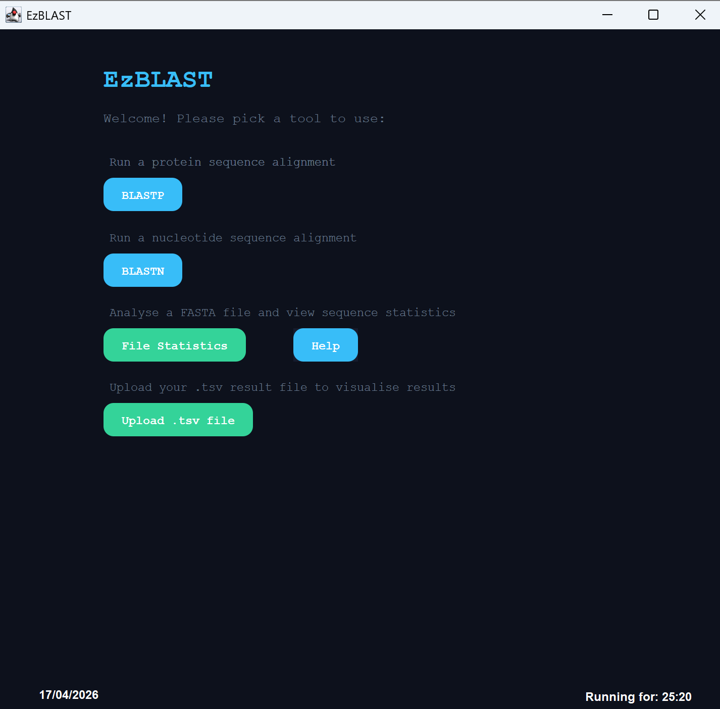
The user selects the BLASTP algorithm
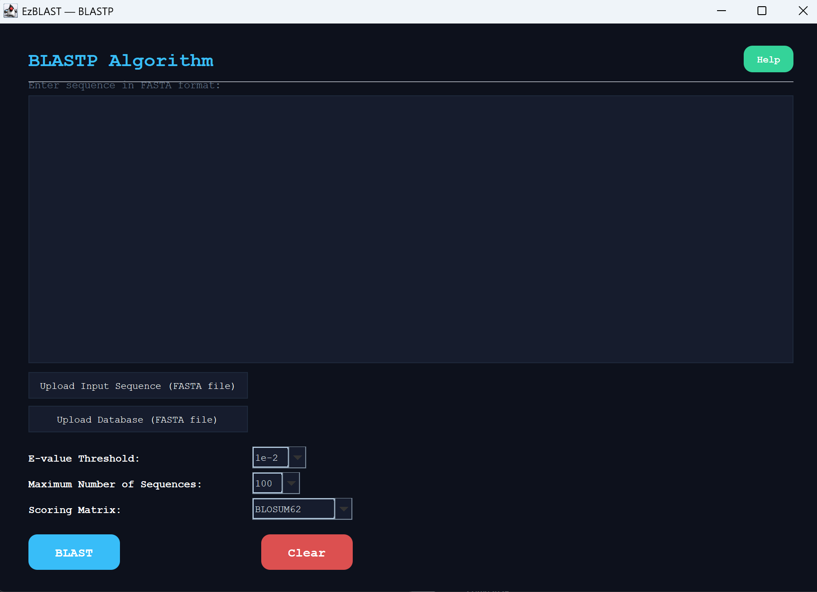
The user gives the sequence
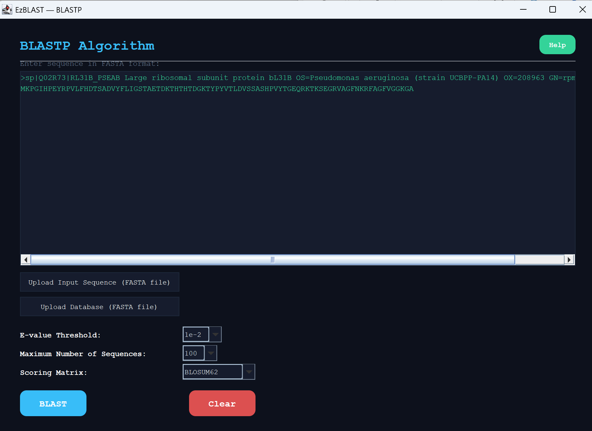
And runs the blast
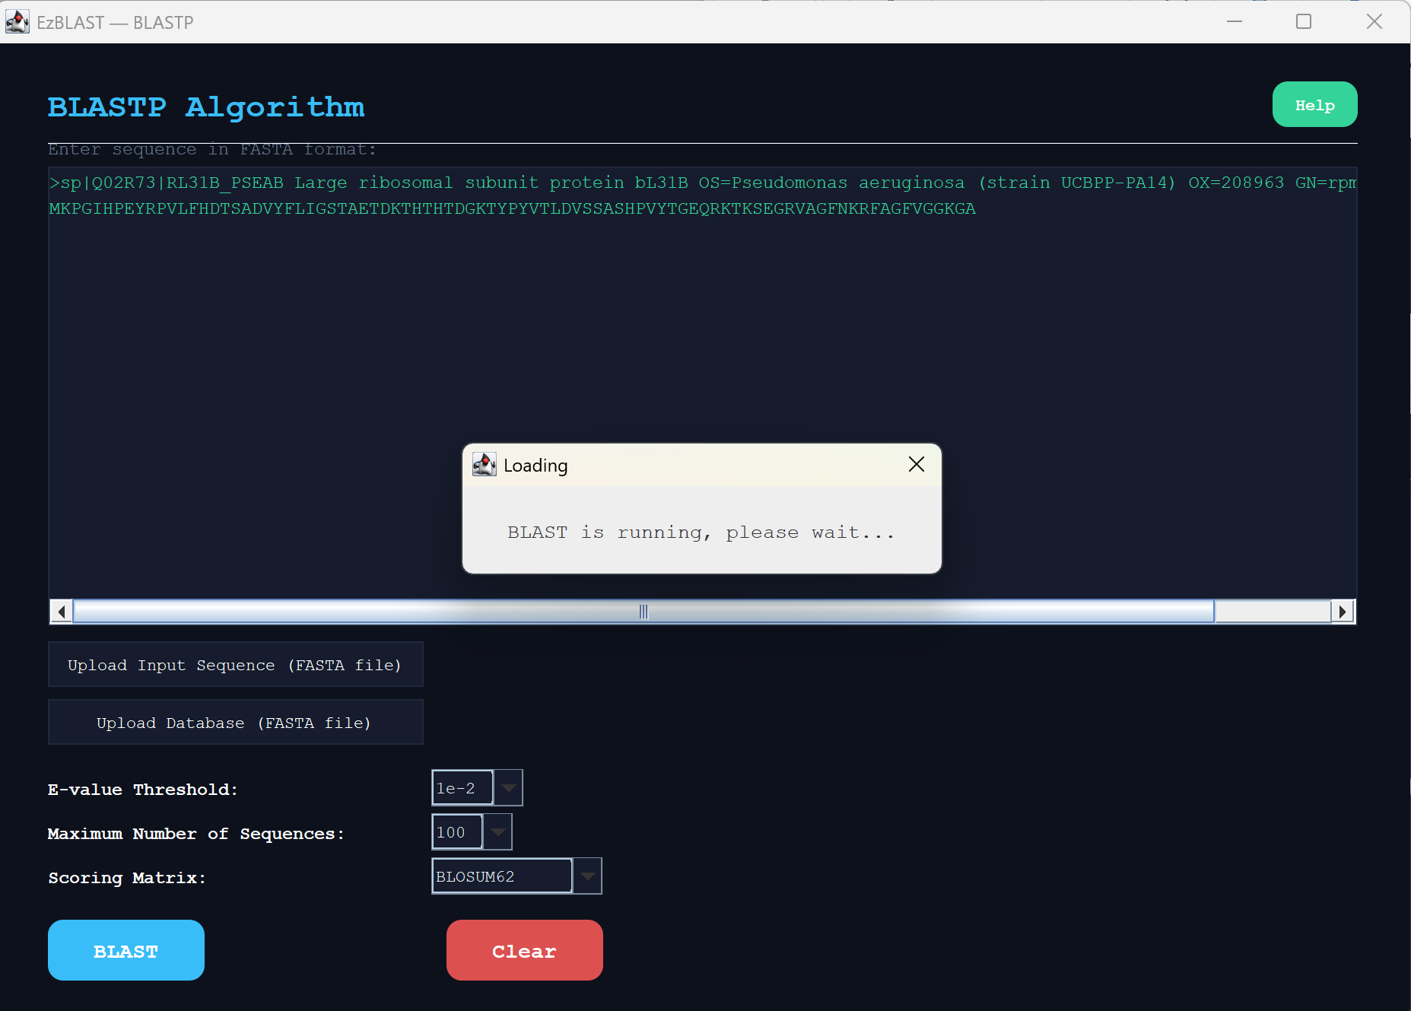
The user inspects the results and decides to export
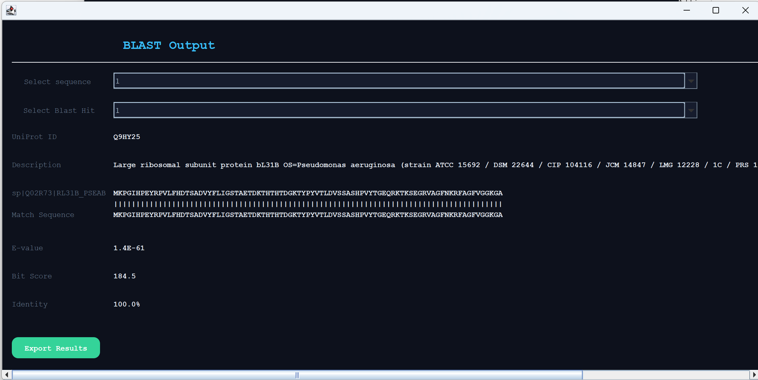
The user selects a file name and location
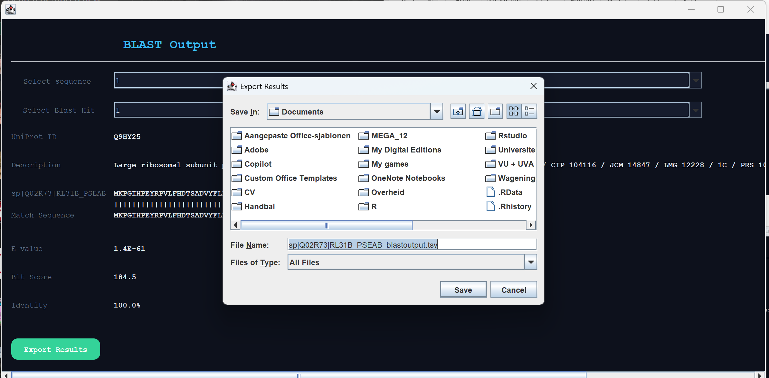
Results were successfully saved
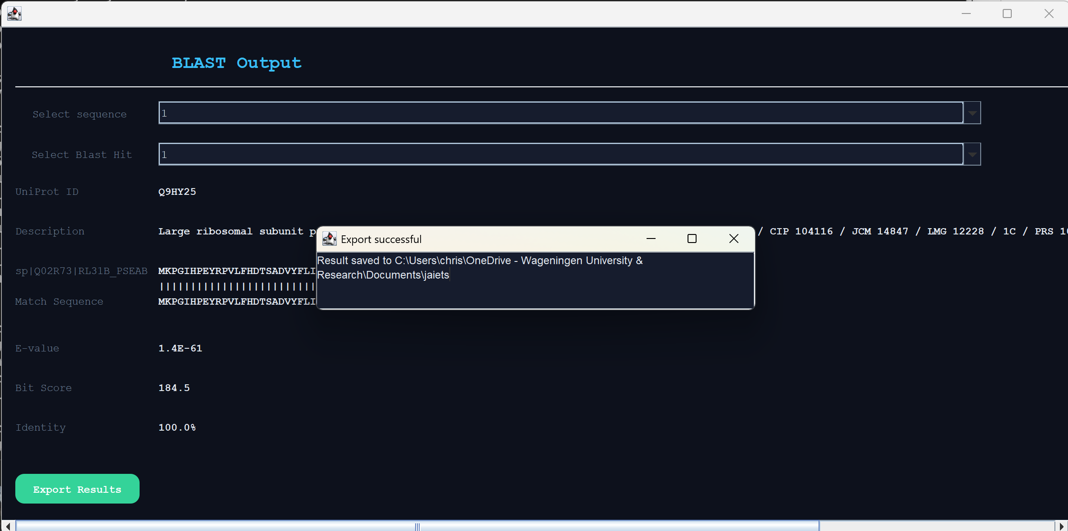
User may go back to main screen

And decides to inspect his file again by clicking on upload .tsv file button

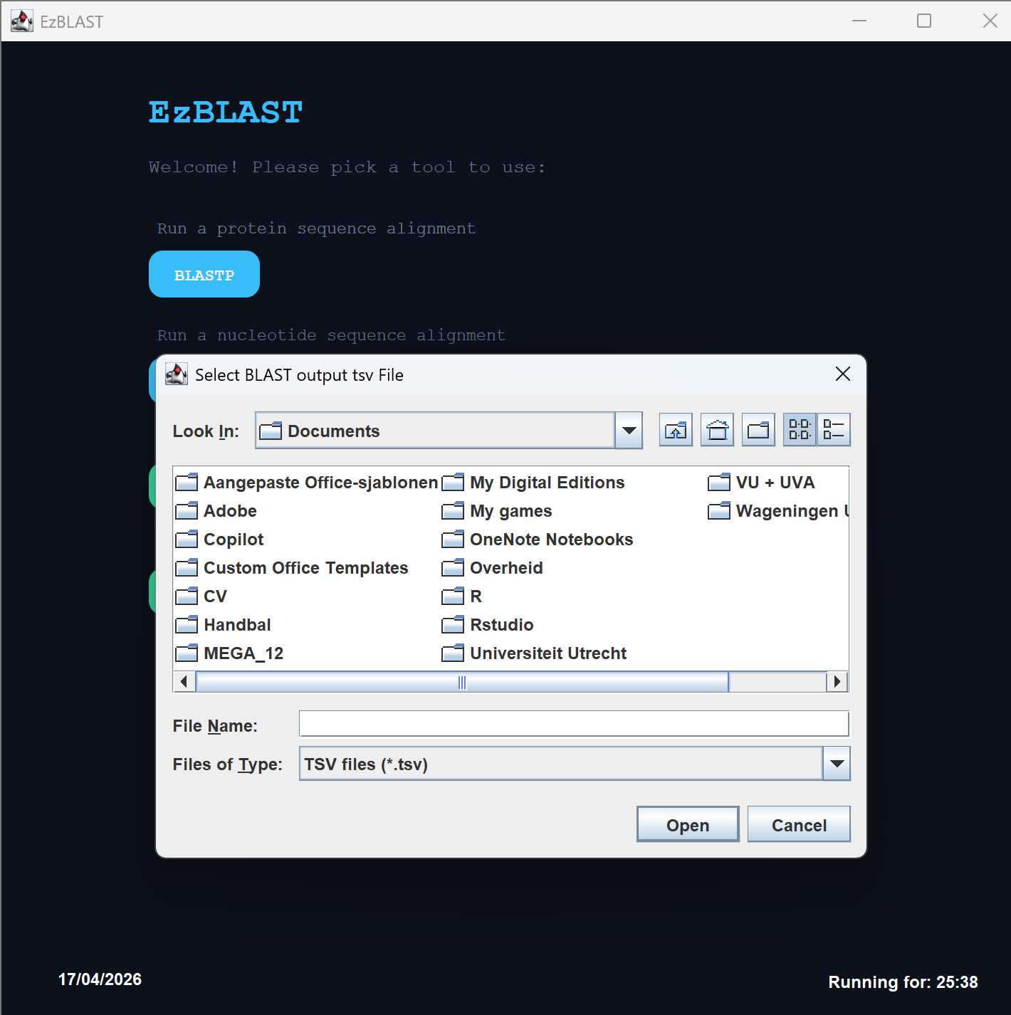
The correct file is chosen and the user can inspect is output once more.
